An Abrupt Climate Change Scenario and Its Implications for United States National Security

October 2003

By Peter Schwartz and Doug Randall

Imagining the Unthinkable

The purpose of this report is to imagine the unthinkable – to push the boundaries of current research on climate change so we may better understand the potential implications on United States national security.

We have interviewed leading climate change scientists, conducted additional research, and reviewed several iterations of the scenario with these experts. The scientists support this project, but caution that the scenario depicted is extreme in two fundamental ways. First, they suggest the occurrences we outline would most likely happen in a few regions, rather than on globally. Second, they say the magnitude of the event may be considerably smaller.

We have created a climate change scenario that although not the most likely, is plausible, and would challenge United States national security in ways that should be considered immediately.

Executive Summary

There is substantial evidence to indicate that significant global warming will occur during the 21st century. Because changes have been gradual so far, and are projected to be similarly gradual in the future, the effects of global warming have the potential to be manageable for most nations. Recent research, however, suggests that there is a possibility that this gradual global warming could lead to a relatively abrupt slowing of the ocean’s thermohaline conveyor, which could lead to harsher winter weather conditions, sharply reduced soil moisture, and more intense winds in certain regions that currently provide a significant fraction of the world’s food production. With inadequate preparation, the result could be a significant drop in the human carrying capacity of the Earth’s environment.

The research suggests that once temperature rises above some threshold, adverse weather conditions could develop relatively abruptly, with persistent changes in the atmospheric circulation causing drops in some regions of 5-10 degrees Fahrenheit in a single decade. Paleoclimatic evidence suggests that altered climatic patterns could last for as much as a century, as they did when the ocean conveyor collapsed 8,200 years ago, or, at the extreme, could last as long as 1,000 years as they did during the Younger Dryas, which began about 12,700 years ago.

In this report, as an alternative to the scenarios of gradual climatic warming that are so common, we outline an abrupt climate change scenario patterned after the 100-year event that occurred about 8,200 years ago. This abrupt change scenario is characterized by the following conditions:
- Annual average temperatures drop by up to 5 degrees Fahrenheit over Asia and North America and 6 degrees Fahrenheit in northern Europe
- Annual average temperatures increase by up to 4 degrees Fahrenheit in key areas throughout Australia, South America, and southern Africa.
- Drought persists for most of the decade in critical agricultural regions and in the water resource regions for major population centers in Europe and eastern North America.
- Winter storms and winds intensify, amplifying the impacts of the changes. Western Europe and the North Pacific experience enhanced winds.

The report explores how such an abrupt climate change scenario could potentially de-stabilize the geo-political environment, leading to skirmishes, battles, and even war due to resource constraints such as:

- Food shortages due to decreases in net global agricultural production
- Decreased availability and quality of fresh water in key regions due to shifted precipitation patters, causing more frequent floods and droughts
- Disrupted access to energy supplies due to extensive sea ice and storminess

As global and local carrying capacities are reduced, tensions could mount around the world, leading to two fundamental strategies: defensive and offensive. Nations with the resources to do so may build virtual fortresses around their countries, preserving resources for themselves. Less fortunate nations especially those with ancient enmities with their neighbors, may initiate in struggles for access to food, clean water, or energy. Unlikely alliances could be formed as defense priorities shift and the goal is resources for survival rather than religion, ideology, or national honor.

This scenario poses new challenges for the United States, and suggests several steps to be taken:
- Improve predictive climate models to allow investigation of a wider range of scenarios and to anticipate how and where changes could occur
- Assemble comprehensive predictive models of the potential impacts of abrupt climate change to improve projections of how climate could influence food, water, and energy
- Create vulnerability metrics to anticipate which countries are most vulnerable to climate change and therefore, could contribute materially to an increasingly disorderly and potentially violent world.
- Identify no-regrets strategies such as enhancing capabilities for water management
- Rehearse adaptive responses
- Explore local implications
- Explore geo-engineering options that control the climate.

There are some indications today that global warming has reached the threshold where the thermohaline circulation could start to be significantly impacted. These indications include observations documenting that the North Atlantic is increasingly being freshened by melting glaciers, increased precipitation, and fresh water runoff making it substantially less salty over the past 40 years.

This report suggests that, because of the potentially dire consequences, the risk of abrupt climate change, although uncertain and quite possibly small, should be elevated beyond a scientific debate to a U.S. national security concern.

Climate Change
Cold
Dry
Storms
Reduction in Carrying
Capacity
Food
Water
Energy
National Security
Implications
Border management
Global conflict
Economic malaise

An Abrupt Climate Change Scenario and Its Implications for United States National Security

October 2003

Introduction
When most people think about climate change, they imagine gradual increases in temperature and only marginal changes in other climatic conditions, continuing indefinitely or even leveling off at some time in the future. The conventional wisdom is that modern civilization will either adapt to whatever weather conditions we face and that the pace of climate change will not overwhelm the adaptive capacity of society, or that our efforts such as those embodied in the Kyoto protocol will be sufficient to mitigate the impacts. The IPCC documents the threat of gradual climate change and its impact to food supplies and other resources of importance to humans will not be so severe as to create security threats. Optimists assert that the benefits from technological innovation will be able to outpace the negative effects of climate change.

Climatically, the gradual change view of the future assumes that agriculture will continue to thrive and growing seasons will lengthen. Northern Europe, Russia, and North America will prosper agriculturally while southern Europe, Africa, and Central and South America will suffer from increased dryness, heat, water shortages, and reduced production. Overall, global food production under many typical climate scenarios increases. This view of climate change may be a dangerous act of self-deception, as increasingly we are facing weather related disasters -- more hurricanes, monsoons, floods, and dry-spells – in regions around the world.

Weather-related events have an enormous impact on society, as they influence food supply, conditions in cities and communities, as well as access to clean water and energy. For example, a recent report by the Climate Action Network of Australia projects that climate change is likely to reduce rainfall in the rangelands, which could lead to a 15 per cent drop in grass productivity. This, in turn, could lead to reductions in the average weight of cattle by 12 per cent, significantly reducing beef supply. Under such conditions, dairy cows are projected to produce 30% less milk, and new pests are likely to spread in fruit-growing areas. Additionally, such conditions are projected to lead to 10% less water for drinking. Based on model projections of coming change conditions such as these could occur in several food producing regions around the world at the same time within the next 15-30years, challenging the notion that society’s ability to adapt will make climate change manageable.

With over 400 million people living in drier, subtropical, often over-populated and economically poor regions today, climate change and its follow-on effects pose a severe risk to political, economic, and social stability. In less prosperous regions, where countries lack the resources and capabilities required to adapt quickly to more severe conditions, the problem is very likely to be exacerbated. For some countries, climate change could become such a challenge that mass emigration results as the desperate peoples seek better lives in regions such as the United States that have the resources to adaptation.

Because the prevailing scenarios of gradual global warming could cause effects like the ones described above, an increasing number of business leaders, economists, policy makers, and politicians are concerned about the projections for further change and are working to limit human influences on the climate. But, these efforts may not be sufficient or be implemented soon enough.

Rather than decades or even centuries of gradual warming, recent evidence suggests the possibility that a more dire climate scenario may actually be unfolding. This is why GBN is working with OSD to develop a plausible scenario for abrupt climate change that can be used to explore implications for food supply, health and disease, commerce and trade, and their consequences for national security.

While future weather patterns and the specific details of abrupt climate change cannot be predicted accurately or with great assurance, the actual history of climate change provides some useful guides. Our goal is merely to portray a plausible scenario, similar to one which has already occurred in human experieince, for which there is reasonable evidence so that we may further explore potential implications for United States national security.

Creating the Scenario: Reviewing History

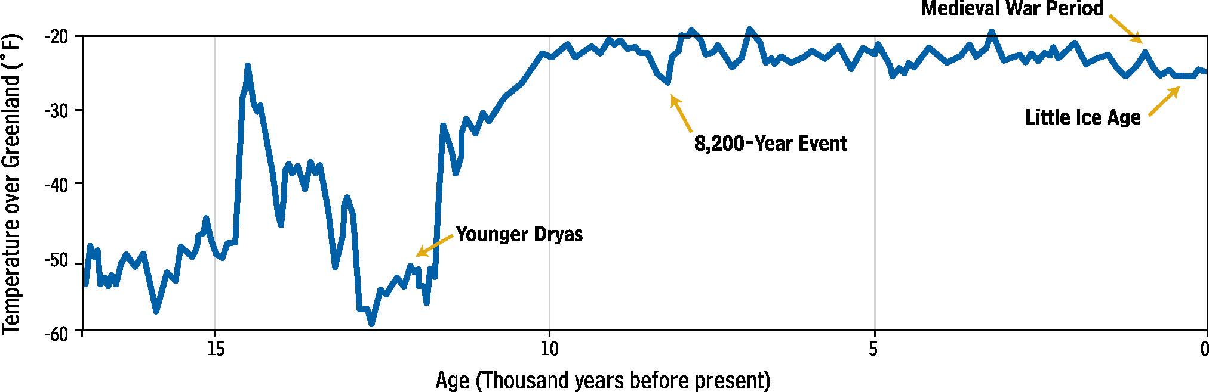

The above graphic, derived from sampling of an ice core in Greenland, shows a historical tendency for particular regions to experience periods of abrupt cooling within periods of general warming.

The Cooling Event 8,200 Years Ago
The climate change scenario outlined in this report is modeled on a century-long climate event that records from an ice core in Greenland indicate occurred 8,200 years ago. Immediately following an extended period of warming, much like the phase we appear to be in today, there was a sudden cooling . Average annual temperatures in Greenland dropped by roughly 5 degrees Fahrenheit, and temperature decreases nearly this large are likely to have occurred throughout the North Atlantic region. During the 8,200 event severe winters in Europe and some other areas caused glaciers to advance, rivers to freeze, and agricultural lands to be less productive. Scientific evidence suggests that this event was associated with, and perhaps caused by, a collapse of the ocean’s conveyor following a period of gradual warming.

Longer ice core and oceanic records suggest that there may have been as many as eight rapid cooling episodes in the past 730,000 years, and sharp reductions in the ocean conveyer--a phenomenon that may well be on the horizon – are a likely suspect in causing such shifts in climate.

The Younger Dryas
About 12,700 years ago, also associated with an apparent collapse of the thermohaline circulation, there was a cooling of at least 27 degrees Fahrenheit in Greenland, and substantial change throughout the North Atlantic region as well, this time lasting 1,300 years. The remarkable feature of the Younger Dryas event was that it happened in a series of decadal drops of around 5 degrees, and then the cold, dry weather persisted for over 1,000 years. While this event had an enormous effect on the ocean and land surrounding Europe (causing icebergs to be found as far south as the coast of Portugal), its impact would be more severe today – in our densely populated society. It is the more recent periods of cooling that appear to be intimately connected with changes to civilization, unrest, inhabitability of once desirable land, and even the demise of certain populations.

The Little Ice Age
Beginning in the 14th century, the North Atlantic region experienced a cooling that lasted until the mid-19th century. This cooling may have been caused by a significant slowing of the ocean conveyor, although it is more generally thought that reduced solar output and/or volcanic eruptions may have prompted the oceanic changes. This period, often referred to as the Little Ice Age, which lasted from 1300 to 1850, brought severe winters, sudden climatic shifts, and profound agricultural, economic, and political impacts to Europe.

The period was marked by persistent crop failures, famine, disease, and population migration, perhaps most dramatically felt by the Norse, also known as the Vikings, who inhabited Iceland and later Greenland. Ice formations along the coast of Greenland prevented merchants from getting their boats to Greenland and fisherman from getting fish for entire winters. As a result, farmers were forced to slaughter their poorly fed livestock -- because of a lack of food both for the animals and themselves -- but without fish, vegetables, and grains, there was not enough food to feed the population.

Famine, caused in part by the more severe climatic conditions, is reported to have caused tens of thousands of deaths between 1315 and 1319 alone. The general cooling also apparently drove the Vikings out of Greenland -- and some say was a contributing cause for that society’s demise.

While climate crises like the Little Ice Age aren’t solely responsible for the death of civilizations, it’s undeniable that they have a large impact on society. It has been less than 175 years since 1 million people died due to the Irish Potato famine, which also was induced in part by climate change.

A Climate Change Scenario For the Future
The past examples of abrupt climate change suggest that it is prudent to consider an abrupt climate change scenario for the future as plausible, especially because some recent scientific findings suggest that we could be on the cusp of such an event. The future scenario that we have constructed is based on the 8,200 years before present event, which was much warmer and far briefer than the Younger Dryas, but more severe than the Little Ice Age. This scenario makes plausible assumptions about which parts of the globe are likely to be colder, drier, and windier. Although intensified research could help to refine the assumptions, there is no way to confirm the assumptions on the basis of present models.

Rather than predicting how climate change will happen, our intent is to dramatize the impact climate change could have on society if we are unprepared for it. Where we describe concrete weather conditions and implications, our aim is to further the strategic conversation rather than to accurately forecast what is likely to happen with a high degree of certainty. Even the most sophisticated models cannot predict the details of how the climate change will unfold, which regions will be impacted in which ways, and how governments and society might respond. However, there appears to be general agreement in the scientific community that an extreme case like the one depicted below is not implausible. Many scientists would regard this scenario as extreme both in how soon it develops, how large, rapid and ubiquitous the climate changes are. But history tells us that sometimes the extreme cases do occur, there is evidence that it might be and it is DOD’s job to consider such scenarios.

Keep in mind that the duration of this event could be decades, centuries, or millennia and it could begin this year or many years in the future. In the climate change disruption scenario proposed here, we consider a period of gradual warming leading to 2010 and then outline the following ten years, when like in the 8,200 event, an abrupt change toward cooling in the pattern of weather conditions change is assumed to occur.

Warming Up to 2010

Following the most rapid century of warming experienced by modern civilization, the first ten years of the 21st century see an acceleration of atmospheric warming, as average temperatures worldwide rise by .5 degrees Fahrenheit per decade and by as much as 2 degrees Fahrenheit per decade in the harder hit regions. Such temperature changes would vary both by region and by season over the globe, with these finer scale variations being larger or smaller than the average change. What would be very clear is that the planet is continuing the warming trend of the late 20th century.

Most of North America, Europe, and parts of South America experience 30% more days with peak temperatures over 90 degrees Fahrenheit than they did a century ago, with far fewer days below freezing. In addition to the warming, there are erratic weather patterns: more floods, particularly in mountainous regions, and prolonged droughts in grain-producing and coastal-agricultural areas. In general, the climate shift is an economic nuisance, generally affecting local areas as storms, droughts, and hot spells impact agriculture and other climate-dependent activities. (More French doctors remain on duty in August, for example.) The weather pattern, though, is not yet severe enough or widespread enough to threaten the interconnected global society or United States national security.

Warming Feedback Loops
As temperatures rise throughout the 20th century and into the early 2000s potent positive feedback loops kick-in, accelerating the warming from .2 degrees Fahrenheit, to .4 and eventually .5 degrees Fahrenheit per year in some locations. As the surface warms, the hydrologic cycle (evaporation, precipitation, and runoff) accelerates causing temperatures to rise even higher.

Water vapor, the most powerful natural greenhouse gas, traps additional heat and brings average surface air temperatures up. As evaporation increases, higher surface air temperatures cause drying in forests and grasslands, where animals graze and farmers grow grain. As trees die and burn, forests absorb less carbon dioxide, again leading to higher surface air temperatures as well as fierce and uncontrollable forest fires Further, warmer temperatures melt snow cover in mountains, open fields, high-latitude tundra areas, and permafrost throughout forests in cold-weather areas. With the ground absorbing more and reflecting less of the sun’s rays, temperatures increase even higher.

By 2005 the climatic impact of the shift is felt more intensely in certain regions around the world. More severe storms and typhoons bring about higher storm surges and floods in low-lying islands such as Tarawa and Tuvalu (near New Zealand). In 2007, a particularly severe storm causes the ocean to break through levees in the Netherlands making a few key coastal cities such as The Hague unlivable. Failures of the delta island levees in the Sacramento River region in the Central Valley of California creates an inland sea and disrupts the aqueduct system transporting water from northern to southern California because salt water can no longer be kept out of the area during the dry season. Melting along the Himalayan glaciers accelerates, causing some Tibetan people to relocate. Floating ice in the northern polar seas, which had already lost 40% of its mass from 1970 to 2003, is mostly gone during summer by 2010. As glacial ice melts, sea levels rise and as wintertime sea extent decreases, ocean waves increase in intensity, damaging coastal cities. Additionally millions of people are put at risk of flooding around the globe (roughly 4 times 2003 levels), and fisheries are disrupted as water temperature changes cause fish to migrate to new locations and habitats, increasing tensions over fishing rights.

Each of these local disasters caused by severe weather impacts surrounding areas whose natural, human, and economic resources are tapped to aid in recovery. The positive feedback loops and acceleration of the warming pattern begin to trigger responses that weren’t previously imagined, as natural disasters and stormy weather occur in both developed and lesser-developed nations. Their impacts are greatest in less-resilient developing nations, which do not have the capacity built into their social, economic, and agricultural systems to absorb change.

As melting of the Greenland ice sheet exceeds the annual snowfall, and there is increasing freshwater runoff from high latitude precipitation, the freshening of waters in the North Atlantic Ocean and the seas between Greenland and Europe increases. The lower densities of these freshened waters in turn pave the way for a sharp slowing of the thermohaline circulation system.

The Period from 2010 to 2020

Thermohaline Circulation Collapse
After roughly 60 years of slow freshening, the thermohaline collapse begins in 2010, disrupting the temperate climate of Europe, which is made possible by the warm flows of the Gulf Stream (the North Atlantic arm of the global thermohaline conveyor). Ocean circulation patterns change, bringing less warm water north and causing an immediate shift in the weather in Northern Europe and eastern North America. The North Atlantic Ocean continues to be affected by fresh water coming from melting glaciers, Greenland’s ice sheet, and perhaps most importantly increased rainfall and runoff. Decades of high-latitude warming cause increased precipitation and bring additional fresh water to the salty, dense water in the North, which is normally affected mainly by warmer and saltier water from the Gulf Stream. That massive current of warm water no longer reaches far into the North Atlantic. The immediate climatic effect is cooler temperatures in Europe and throughout much of the Northern Hemisphere and a dramatic drop in rainfall in many key agricultural and populated areas. However, the effects of the collapse will be felt in fits and starts, as the traditional weather patterns re-emerge only to be disrupted again—for a full decade.

The dramatic slowing of the thermohaline circulation is anticipated by some ocean researchers, but the United States is not sufficiently prepared for its effects, timing, or intensity. Computer models of the climate and ocean systems, though improved, were unable to produce sufficiently consistent and accurate information for policymakers. As weather patterns shift in the years following the collapse, it is not clear what type of weather future years will bring. While some forecasters believe the cooling and dryness is about to end, others predict a new ice age or a global drought, leaving policy makers and the public highly uncertain about the future climate and what to do, if anything. Is this merely a “blip” of little importance or a fundamental change in the Earth’s climate, requiring an urgent massive human response?

Cooler, Drier, Windier Conditions for Continental Areas of the Northern Hemisphere

The Weather Report: 2010-2020
- Drought persists for the entire decade in critical agricultural regions and in the areas around major population centers in Europe and eastern North America.
- Average annual temperatures drop by up to 5 degrees Fahrenheit over Asia and North America and up to 6 degrees Fahrenheit in Europe.
- Temperatures increase by up to 4 degrees Fahrenheit in key areas throughout Australia, South America, and southern Africa.
- Winter storms and winds intensify, amplifying the impact of the changes. Western Europe and the North Pacific face enhanced westerly winds.

Each of the years from 2010-2020 sees average temperature drops throughout Northern Europe, leading to as much as a 6 degree Fahrenheit drop in ten years. Average annual rainfall in this region decreases by nearly 30%; and winds are up to 15% stronger on average. The climatic conditions are more severe in the continental interior regions of northern Asia and North America.

The effects of the drought are more devastating than the unpleasantness of temperature decreases in the agricultural and populated areas. With the persistent reduction of precipitation in these areas, lakes dry-up, river flow decreases, and fresh water supply is squeezed, overwhelming available conservation options and depleting fresh water reserves. The Mega-droughts begin in key regions in Southern China and Northern Europe around 2010 and last throughout the full decade. At the same time, areas that were relatively dry over the past few decades receive persistent years of torrential rainfall, flooding rivers, and regions that traditionally relied on dryland agriculture.

In the North Atlantic region and across northern Asia, cooling is most pronounced in the heart of winter -- December, January, and February -- although its effects linger through the seasons, the cooling becomes increasingly intense and less predictable. As snow accumulates in mountain regions, the cooling spreads to summertime. In addition to cooling and summertime dryness, wind pattern velocity strengthens as the atmospheric circulation becomes more zonal.

While weather patterns are disrupted during the onset of the climatic change around the globe, the effects are far more pronounced in Northern Europe for the first five years after the thermohaline circulation collapse.
By the second half of this decade, the chill and harsher conditions spread deeper into Southern Europe, North America, and beyond. Northern Europe cools as a pattern of colder weather lengthens the time that sea ice is present over the northern North Atlantic Ocean, creating a further cooling influence and extending the period of wintertime surface air temperatures. Winds pick up as the atmosphere tries to deal with the stronger pole-to-equator temperature gradient. Cold air blowing across the European continent causes especially harsh conditions for agriculture. The combination of wind and dryness causes widespread dust storms and soil loss.

Signs of incremental warming appear in the southern most areas along the Atlantic Ocean, but the dryness doesn’t let up. By the end of the decade, Europe’s climate is more like Siberia’s.
An Alternative Scenario for the Southern Hemisphere
There is considerable uncertainty about the climate dynamics of the Southern Hemisphere, mainly due to less paleoclimatic data being available than for the Northern Hemisphere. Weather patterns in key regions in the Southern Hemisphere could mimic those of the Northern Hemisphere, becoming colder, drier, and more severe as heat flows from the tropics to the Northern Hemisphere, trying to thermodynamically balance the climatic system. Alternatively, the cooling of the Northern Hemisphere may lead to increased warmth, precipitation, and storms in the south, as the heat normally transported away from equatorial regions by the ocean currents becomes trapped and as greenhouse gas warming continues to accelerate. Either way, it is not implausible that abrupt climate change will bring extreme weather conditions to many of the world’s key population and growing regions at the same time – stressing global food, water, and energy supply.

The Regions: 2010 to 2020
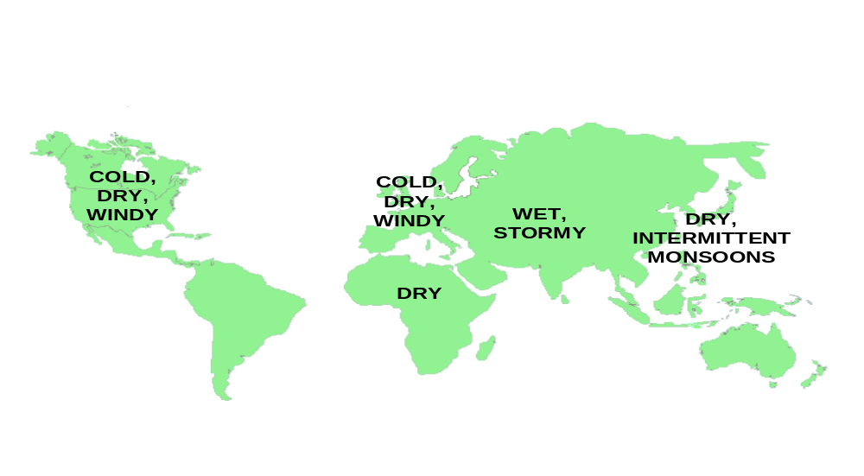

The above graphic shows a simplified view of the weather patterns portrayed in this scenario.

Europe. Hit hardest by the climatic change, average annual temperatures drop by 6 degrees Fahrenheit in under a decade, with more dramatic shifts along the Northwest coast. The climate in northwestern Europe is colder, drier, and windier, making it more like Siberia. Southern Europe experiences less of a change but still suffers from sharp intermittent cooling and rapid temperature shifts. Reduced precipitation causes soil loss to become a problem throughout Europe, contributing to food supply shortages. Europe struggles to stem emigration out of Scandinavian and northern European nations in search of warmth as well as immigration from hard-hit countries in Africa and elsewhere.

United States. Colder, windier, and drier weather makes growing seasons shorter and less productive throughout the northeastern United States, and longer and drier in the southwest. Desert areas face increasing windstorms, while agricultural areas suffer from soil loss due to higher wind speeds and reduced soil moisture. The change toward a drier climate is especially pronounced in the southern states. Coastal areas that were at risk during the warming period remain at risk, as rising ocean levels continues along the shores. The United States turns inward, committing its resources to feeding its own population, shoring-up its borders, and managing the increasing global tension.

China. China, with its high need for food supply given its vast population, is hit hard by a decreased reliability of the monsoon rains. Occasional monsoons during the summer season are welcomed for their precipitation, but have devastating effects as they flood generally denuded land. Longer, colder winters and hotter summers caused by decreased evaporative cooling because of reduced precipitation stress already tight energy and water supplies. Widespread famine causes chaos and internal struggles as a cold and hungry China peers jealously across the Russian and western borders at energy resources.

Bangladesh. Persistent typhoons and a higher sea level create storm surges that cause significant coastal erosion, making much of Bangladesh nearly uninhabitable. Further, the rising sea level contaminates fresh water supplies inland, creating a drinking water and humanitarian crisis. Massive emigration occurs, causing tension in China and India, which are struggling to manage the crisis inside their own boundaries.

East Africa. Kenya, Tanzania, and Mozambique face slightly warmer weather, but are challenged by persistent drought. Accustomed to dry conditions, these countries were the least influenced by the changing weather conditions, but their food supply is challenged as major grain producing regions suffer.

Australia. A major food exporter, Australia struggles to supply food around the globe, as its agriculture is not severely impacted by more subtle changes in its climate. But the large uncertainties about Southern Hemisphere climate change make this benign conclusion suspect.

Impact on Natural Resources
The changing weather patterns and ocean temperatures affect agriculture, fish and wildlife, water and energy. Crop yields, affected by temperature and water stress as well as length of growing season fall by 10-25% and are less predictable as key regions shift from a warming to a cooling trend. As some agricultural pests die due to temperature changes, other species spread more readily due to the dryness and windiness – requiring alternative pesticides or treatment regiments. Commercial fishermen that typically have rights to fish in specific areas will be ill equipped for the massive migration of their prey.

With only five or six key grain-growing regions in the world (US, Australia, Argentina, Russia, China, and India), there is insufficient surplus in global food supplies to offset severe weather conditions in a few regions at the same time – let alone four or five. The world’s economic interdependence make the United States increasingly vulnerable to the economic disruption created by local weather shifts in key agricultural and high population areas around the world. Catastrophic shortages of water and energy supply – both which are stressed around the globe today – cannot be quickly overcome.

Impact on National Security
Human civilization began with the stabilization and warming of the Earth’s climate. A colder unstable climate meant that humans could neither develop agriculture or permanent settlements. With the end of the Younger Dryas and the warming and stabilization that followed, humans could learn the rhythms of agriculture and settle in places whose climate was reliably productive. Modern civilization has never experienced weather conditions as persistently disruptive as the ones outlined in this scenario. As a result, the implications for national security outlined in this report are only hypothetical. The actual impacts would vary greatly depending on the nuances of the weather conditions, the adaptability of humanity, and decisions by policymakers.

Violence and disruption stemming from the stresses created by abrupt changes in the climate pose a different type of threat to national security than we are accustomed to today. Military confrontation may be triggered by a desperate need for natural resources such as energy, food and water rather than by conflicts over ideology, religion, or national honor. The shifting motivation for confrontation would alter which countries are most vulnerable and the existing warning signs for security threats.

There is a long-standing academic debate over the extent to which resource constraints and environmental challenges lead to inter-state conflict. While some believe they alone can lead nations to attack one another, others argue that their primary effect is to act as a trigger of conflict among countries that face pre-existing social, economic, and political tension. Regardless, it seems undeniable that severe environmental problems are likely to escalate the degree of global conflict.

Co-founder and President of the Pacific Institute for Studies in Development, Environment, and Security, Peter Gleick outlines the three most fundamental challenges abrupt climate change poses for national security:

- Food shortages due to decreases in agricultural production
- Decreased availability and quality of fresh water due to flooding and droughts
- Disrupted access to strategic minerals due to ice and storms

In the event of abrupt climate change, it’s likely that food, water, and energy resource constraints will first be managed through economic, political, and diplomatic means such as treaties and trade embargoes. Over time though, conflicts over land and water use are likely to become more severe – and more violent. As states become increasingly desperate, the pressure for action will grow.

Decreasing Carrying Capacity
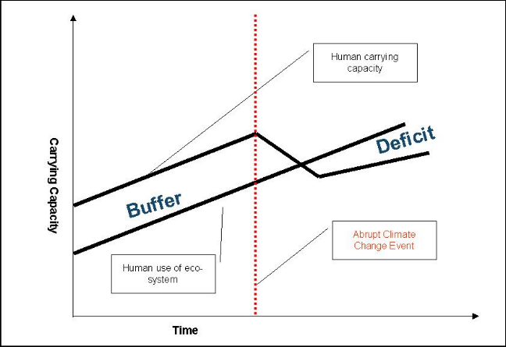

The graphic shows how abrupt climate change may cause human carrying capacity to fall below usage of the eco-system, suggesting insufficient resources leading to a contraction of the population through war, disease, and famine.

Today, carrying capacity, which is the ability for the Earth and its natural ecosystems including social, economic, and cultural systems to support the finite number of people on the planet, is being challenged around the world. According to the International Energy Agency, global demand for oil will grow by 66% in the next 30 years, but it’s unclear where the supply will come from. Clean water is similarly constrained in many areas around the world. With 815 million people receiving insufficient sustenance worldwide, some would say that as a globe, we’re living well above our carrying capacity, meaning there are not sufficient natural resources to sustain our behavior.

Many point to technological innovation and adaptive behavior as a means for managing the global ecosystem. Indeed it has been technological progress that has increased carrying capacity over time. Over centuries we have learned how to produce more food, energy and access more water. But will the potential of new technologies be sufficient when a crisis like the one outlined in this scenario hits?

Abrupt climate change is likely to stretch carrying capacity well beyond its already precarious limits. And there’s a natural tendency or need for carrying capacity to become realigned. As abrupt climate change lowers the world’s carrying capacity aggressive wars are likely to be fought over food, water, and energy. Deaths from war as well as starvation and disease will decrease population size, which overtime, will re-balance with carrying capacity.

When you look at carrying capacity on a regional or state level it is apparent that those nations with a high carrying capacity, such as the United States and Western Europe, are likely to adapt most effectively to abrupt changes in climate, because, relative to their population size, they have more resources to call on. This may give rise to a more severe have, have-not mentality, causing resentment toward those nations with a higher carrying capacity. It may lead to finger-pointing and blame, as the wealthier nations tend to use more energy and emit more greenhouse gasses such as CO2 into the atmosphere. Less important than the scientifically proven relationship between CO2 emissions and climate change is the perception that impacted nations have – and the actions they take.

The Link Between Carrying Capacity and Warfare
Steven LeBlanc, Harvard archaeologist and author of a new book called Carrying Capacity, describes the relationship between carrying capacity and warfare. Drawing on abundant archaeological and ethnological data, LeBlanc argues that historically humans conducted organized warfare for a variety of reasons, including warfare over resources and the environment. Humans fight when they outstrip the carrying capacity of their natural environment. Every time there is a choice between starving and raiding, humans raid. From hunter/gatherers through agricultural tribes, chiefdoms, and early complex societies, 25% of a population’s adult males die when war breaks out.

Peace occurs when carrying capacity goes up, as with the invention of agriculture, newly effective bureaucracy, remote trade and technological breakthroughs. Also a large scale die-back such as from plague can make for peaceful times---Europe after its major plagues, North American natives after European diseases decimated their populations (that's the difference between the Jamestown colony failure and Plymouth Rock success). But such peaceful periods are short-lived because population quickly rises to once again push against carrying capacity, and warfare resumes. Indeed, over the millennia most societies define themselves according to their ability to conduct war, and warrior culture becomes deeply ingrained. The most combative societies are the ones that survive.

However in the last three centuries, LeBlanc points out, advanced states have steadily lowered the body count even though individual wars and genocides have grown larger in scale. Instead of slaughtering all their enemies in the traditional way, for example, states merely kill enough to get a victory and then put the survivors to work in their newly expanded economy. States also use their own bureaucracies, advanced technology, and international rules of behavior to raise carrying capacity and bear a more careful relationship to it.

All of that progressive behavior could collapse if carrying capacities everywhere were suddenly lowered drastically by abrupt climate change. Humanity would revert to its norm of constant battles for diminishing resources, which the battles themselves would further reduce even beyond the climatic effects. Once again warfare would define human life.

Conflict Scenario Due to Climate Change

 | Europe | Asia | United States
2010-2020 | 2012: Severe drought and cold push Scandinavian populations southward, push back from EU  2015: Conflict within the EU over food and water supply leads to skirmishes and strained diplomatic relations  2018: Russia joins EU, providing energy resources  2020: Migration from northern countries such as Holland and Germany toward Spain and Italy | 2010: Border skirmishes and conflict in Bangladesh, India, and China, as mass migration occurs toward Burma  2012: Regional instability leads Japan to develop force projection capability  2015: Strategic agreement between Japan and Russia for Siberia and Sakhalin energy resources  2018: China intervenes in Kazakhstan to protect pipelines regularly disrupted by rebels and criminals. | 2010: Disagreements with Canada and Mexico over water increase tension  2012: Flood of refugees to southeast U.S. and Mexico from Caribbean islands  2015: European migration to United States (mostly wealthy)  2016: Conflict with European countries over fishing rights  2018: Securing North America, U.S. forms integrated security alliance with Canada and Mexico  2020: Department of Defense manages borders and refugees from Caribbean and Europe.
2020-2030 | 2020: Increasing: skirmishes over water and immigration  2022: Skirmish between France and Germany over commercial access to Rhine  2025: EU nears collapse  2027: Increasing migration to Mediterranean countries such as Algeria, Morocco, Egypt, and Israel  2030: Nearly 10% of European population moves to a different country | 2020: Persistent conflict in South East Asia; Burma, Laos, Vietnam, India, China  2025: Internal conditions in China deteriorate dramatically leading to civil war and border wars.  2030: Tension growing between China and Japan over Russian energy  * | 2020: Oil prices increase as security of supply is threatened by conflicts in Persian Gulf and Caspian  2025: Internal struggle in Saudi Arabia brings Chinese and U.S. naval forces to Gulf ,in direct confrontation
The chart above outlines some potential military implications of climate change

The two most likely reactions to a sudden drop in carrying capacity due to climate change are defensive and offensive.

The United States and Australia are likely to build defensive fortresses around their countries because they have the resources and reserves to achieve self-sufficiency. With diverse growing climates, wealth, technology, and abundant resources, the United States could likely survive shortened growing cycles and harsh weather conditions without catastrophic losses. Borders will be strengthened around the country to hold back unwanted starving immigrants from the Caribbean islands (an especially severe problem), Mexico, and South America. Energy supply will be shored up through expensive (economically, politically, and morally) alternatives such as nuclear, renewables, hydrogen, and Middle Eastern contracts. Pesky skirmishes over fishing rights, agricultural support, and disaster relief will be commonplace. Tension between the U.S. and Mexico rise as the U.S. reneges on the 1944 treaty that guarantees water flow from the Colorado River. Relief workers will be commissioned to respond to flooding along the southern part of the east coast and much drier conditions inland. Yet, even in this continuous state of emergency the U.S. will be positioned well compared to others. The intractable problem facing the nation will be calming the mounting military tension around the world.

As famine, disease, and weather-related disasters strike due to the abrupt climate change, many countries’ needs will exceed their carrying capacity. This will create a sense of desperation, which is likely to lead to offensive aggression in order to reclaim balance. Imagine eastern European countries, struggling to feed their populations with a falling supply of food, water, and energy, eyeing Russia, whose population is already in decline, for access to its grain, minerals, and energy supply. Or, picture Japan, suffering from flooding along its coastal cities and contamination of its fresh water supply, eying Russia’s Sakhalin Island oil and gas reserves as an energy source to power desalination plants and energy-intensive agricultural processes. Envision Pakistan, India, and China – all armed with nuclear weapons – skirmishing at their borders over refugees, access to shared rivers, and arable land. Spanish and Portuguese fishermen might fight over fishing rights – leading to conflicts at sea. And, countries including the United States would be likely to better secure their borders. With over 200 river basins touching multiple nations, we can expect conflict over access to water for drinking, irrigation, and transportation. The Danube touches twelve nations, the Nile runs though nine, and the Amazon runs through seven.

In this scenario, we can expect alliances of convenience. The United States and Canada may become one, simplifying border controls. Or, Canada might keep its hydropower—causing energy problems in the US. North and South Korea may align to create one technically savvy and nuclear-armed entity. Europe may act as a unified block – curbing immigration problems between European nations – and allowing for protection against aggressors. Russia, with its abundant minerals, oil, and natural gas may join Europe.

In this world of warring states, nuclear arms proliferation is inevitable. As cooling drives up demand, existing hydrocarbon supplies are stretched thin. With a scarcity of energy supply – and a growing need for access -- nuclear energy will become a critical source of power, and this will accelerate nuclear proliferation as countries develop enrichment and reprocessing capabilities to ensure their national security. China, India, Pakistan, Japan, South Korea, Great Britain, France, and Germany will all have nuclear weapons capability, as will Israel, Iran, Egypt, and North Korea.

Managing the military and political tension, occasional skirmishes, and threat of war will be a challenge. Countries such as Japan, that have a great deal of social cohesion (meaning the government is able to effectively engage its population in changing behavior) are most likely to fair well. Countries whose diversity already produces conflict, such as India, South Africa and Indonesia, will have trouble maintaining order. Adaptability and access to resources will be key. Perhaps the most frustrating challenge abrupt climate change will pose is that we’ll never know how far we are into the climate change scenario and how many more years – 10, 100, 1000 --- remain before some kind of return to warmer conditions as the thermohaline circulation starts up again. When carrying capacity drops suddenly, civilization is faced with new challenges that today seem unimaginable.

Could This Really Happen?
Ocean, land, and atmosphere scientists at some of the world’s most prestigious organizations have uncovered new evidence over the past decade suggesting that the plausibility of severe and rapid climate change is higher than most of the scientific community and perhaps all of the political community is prepared for. If it occurs, this phenomenon will disrupt current gradual global warming trends, adding to climate complexity and lack of predictability. And paleoclimatic evidence suggests that such an abrupt climate change could begin in the near future.

The Woods Hole Oceanographic Institute reports that seas surrounding the North Atlantic have become less salty in the past 40 years, which in turn freshens the deep ocean in the North Atlantic. This trend could pave the way for ocean conveyor collapse or slowing and abrupt climate change.

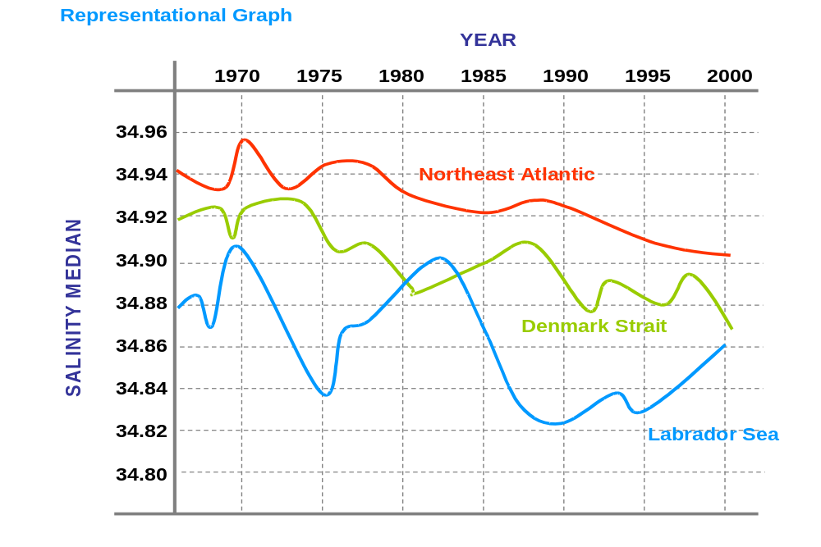

The above graphic shows early evidence that a thermohaline circulation collapse may be imminent, as the North Atlantic is increasingly being freshened by surrounding seas that have become less salty over the past 40 years.

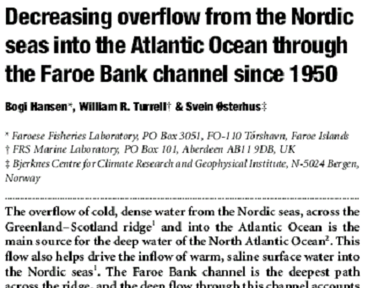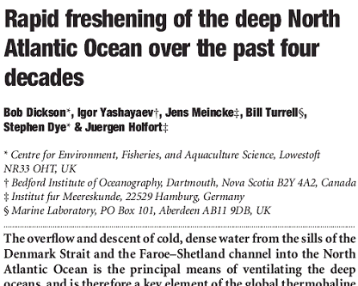

The above two headlines appeared in Nature Magazine in 2001 and 2002, respectively. They suggest that the North Atlantic salinity level may lower, increasing the likelihood of a thermohaline circulation collapse.

With at least eight abrupt climate change events documented in the geological record, it seems that the questions to ask are: When will this happen? What will the impacts be? And, how can we best prepare for it? Rather than: Will this really happen?

Are we prepared for history to repeat itself again?

There is a debate in newspapers around the globe today on the impact of human activity on climate change. Because economic prosperity is correlated with energy use and greenhouse gas emissions, it is often argued that economic progress leads to climate change. Competing evidence suggests that climate change can occur, regardless of human activity as seen in climate events that happened prior to modern society.

It’s important to understand human impacts on the environment – both what’s done to accelerate and decelerate (or perhaps even reverse) the tendency toward climate change. Alternative fuels, greenhouse gas emission controls, and conservation efforts are worthwhile endeavors. In addition, we should prepare for the inevitable effects of abrupt climate change – which will likely come regardless of human activity.

Here are some preliminary recommendations to prepare the United States for abrupt climate change:

- Improve predictive climate models. Further research should be conducted so more confidence can be placed in predictions about climate change. There needs to be a deeper understanding of the relationship between ocean patterns and climate change. This research should focus on historical, current, and predictive forces, and aim to further our understanding of abrupt climate change, how it may happen, and how we’ll know it’s occurring.

- Assemble comprehensive predictive models of climate change impacts. Substantial research should be done on the potential ecological, economic, social, and political impact of abrupt climate change. Sophisticated models and scenarios should be developed to anticipate possible local conditions. A system should be created to identify how climate change may impact the global distribution of social, economic, and political power. These analyses can be used to mitigate potential sources of conflict before they happen.

- Create vulnerability metrics. Metrics should be created to understand a country’s vulnerability to the impacts of climate change. Metrics may include climatic impact on existing agricultural, water, and mineral resources; technical capability; social cohesion and adaptability.

- Identify no-regrets strategies. No-regrets strategies should be identified and implemented to ensure reliable access to food supply and water, and to ensure national security.

- Rehearse adaptive responses. Adaptive response teams should be established to address and prepare for inevitable climate driven events such as massive migration, disease and epidemics, and food and water supply shortages.

- Explore local implications. The first-order effects of climate change are local. While we can anticipate changes in pest prevalence and severity and changes in agricultural productivity, one has to look at very specific locations and conditions to know which pests are of concern, which crops and regions are vulnerable, and how severe impacts will be. Such studies should be undertaken, particularly in strategically important food producing regions.

- Explore geo-engineering options that control the climate. Today, it is easier to warm than to cool the climate, so it might be possible to add various gases, such as hydrofluorocarbons, to the atmosphere to offset the affects of cooling. Such actions, of course, would be studied carefully, as they have the potential to exacerbate conflicts among nations.

Conclusion
It is quite plausible that within a decade the evidence of an imminent abrupt climate shift may become clear and reliable. It is also possible that our models will better enable us to predict the consequences. In that event the United States will need to take urgent action to prevent and mitigate some of the most significant impacts. Diplomatic action will be needed to minimize the likelihood of conflict in the most impacted areas, especially in the Caribbean and Asia. However, large population movements in this scenario are inevitable. Learning how to manage those populations, border tensions that arise and the resulting refugees will be critical. New forms of security agreements dealing specifically with energy, food and water will also be needed. In short, while the US itself will be relatively better off and with more adaptive capacity, it will find itself in a world where Europe will be struggling internally, large number so refugees washing up on its shores and Asia in serious crisis over food and water. Disruption and conflict will be endemic features of life.

R.B. Alley, from The Two Mile Time Machine, 2000.
Adapted from I Yashayaev, Bedford Institute of Oceanography as seen in Abrupt Climate Change, Inevitable Surprises, National Research Council.

