Top of Form

Tony Blair applauds “best practice” extra-care scheme
24 April 2006
On Thursday 20 April 2006 Tony Blair PM and Liam Byrne, Care Services Minister, visited residents living at Notting Hill Housing Trust extra care scheme, 60 Penfold Street, in Westminster.
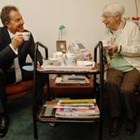
Tony Blair has a cup of tea and a chat with 60 Penfold Street resident, Hannah Smith

It is not every day the Prime Minister visits a Housing Association, otherwise known as a Registered Social Landlord but it does make a difference if the flagship Housing Association where all the directors are members of the Labour Party and many of the staff speak of tales of corruption and its policies are driving through major housing policy in the UK today - without consultation, without accountability and without consent.

Therefore PR spin is essential in order to overturn the reality of Notting Hill Housing Trust which is headquartered in the heart of leafy Hammersmith Grove in Hammersmith, which is at the forefront of dealing with the Blair driver of increased Immigration into the UK, which means coming face to face with greater crime on the streets, the need for harsher laws, all in order to Gerrymander as many Communities in the UK today, so the vote goes to New Labour.

Have we ALL been deceived?

