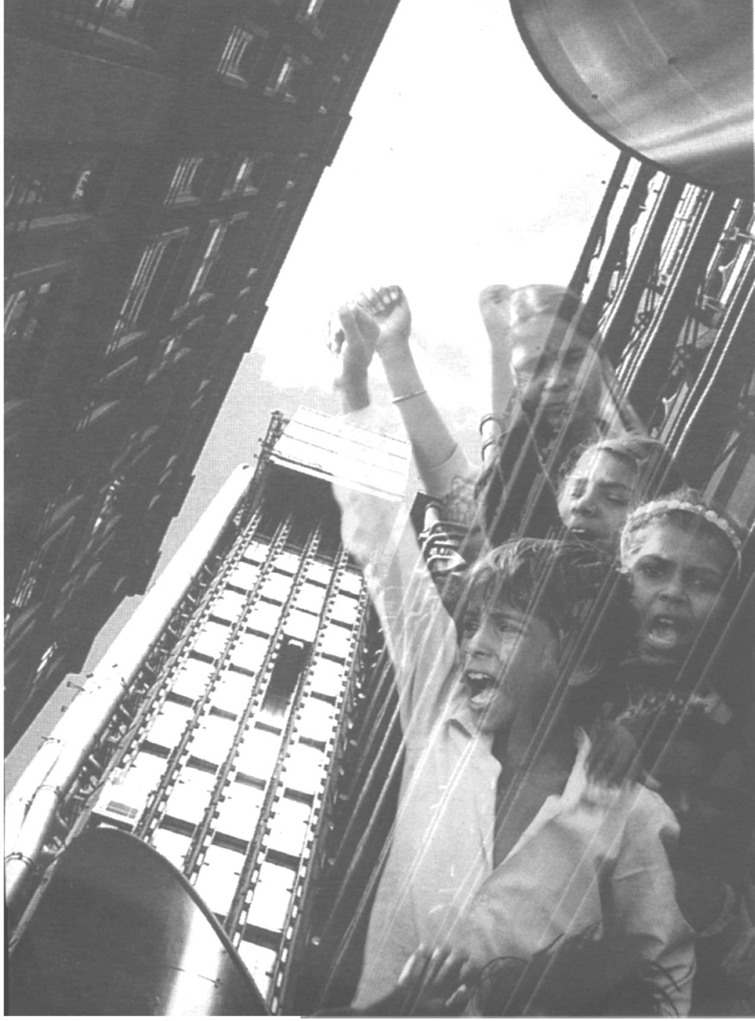
Art Not Oil
Oxford House,
Derbyshire St., Bethnal Green
AUGUST 5th-28th 2005
****
FREE PUBLIC OPENING
THURSDAY
AUGUST 4TH, 6-10pm:
art – live music/poetry – film – sound – food - talk

indignation –
inspiration –
creation…
solution?
www.artnotoil.org.uk

