Rave against the Occupation

Co-existence Tekno performance of Jewish and Arab musicians
In Israel for peace

‘Rave against the Occupation’ is the name given to a series of protests aiming to address the urgent need, felt by tens of thousands of young Israelis, to make a stand against the endless violence and the evil occupation.
‘Rave against the Occupation’ is a mass protest, based on music and pro-peace messages, initiated by a group of politically-unattached young people that are unable to stand by and let this situation continue.

The First Rave against the Occupation:
The first event under this banner was held in May 23rd, 2002, In Tel Aviv Museum’s terrace, and was successful in every respect. Despite the depression that prevailed in a time plagued by many terrorist attacks, the protest was attended by more than 4000 youngsters, who were not seen in previous leftist demonstrations, and some of them joined the anti-war effort afterwards.
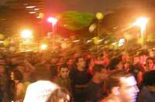
The rave included performances by Arab and Jewish DJs, including leading rap artists from Acre and Lod. The event enjoyed massive press coverage: reports in all the Israeli TV and radio channels, articles in leading national and local newspapers, especially in the nightlife sections, which dealt for the first time with political issues. The news were distributed to more than 130 newspapers throughout the world. Articles supporting the event, or objecting to it, continued to be published in the following weeks, and influenced the public political debate in Israel.
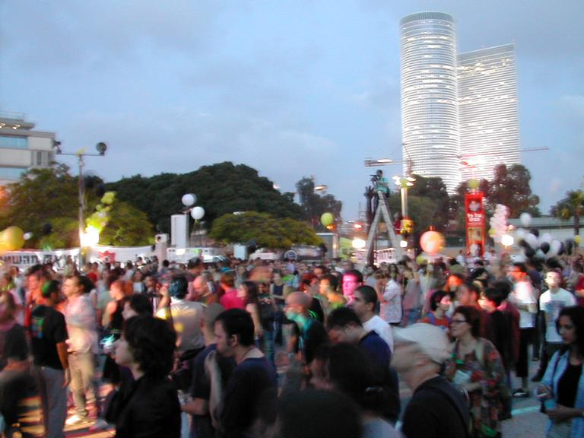
Pictures from the first rave

More exciting than the event’s media impact was the response of the participants. Our major worry before the rave was the possibility of its becoming an escapist festivity. This fear proved to be ungrounded, and the vibe of protest was definitely in the air that night at the museum’s terrace. Many young people came to us during and after the event, saying they felt, for the first time, part of a powerful protest supporting an important message.

The Next Event: A Rave near Arik’s house, in ‘Havat Hashikmim’

During the first rave, the Israeli Prime-Minister Ariel Sharon was at a meeting in the military base of Hakirya, near the museum’s terrace, and wondered aloud about the noise. Well, we are delighted to have disturbed him, and hope to keep doing so until we all wake up from the nightmare he is dictating to us.
We will hold the next rave in front of Sharon’s house, in Havat Hashikmim. We intend to arrive there in a car convoy. At Havat Hashikmim the passengers will disembark from the vehicles and dance under the slogan: “Thanks for the peace, kudos for the security” (Sharon’s election slogan was “I am secure in Sharon’s peace”).
Our hope is that the sight of young people demonstrating right at Sharon’s doorstep, demanding normality and withdrawal from the occupied territories, will give some food for thought to the people of Israel, and maybe even to Sharon himself.

The Important Bit

None of the rave’s initiators, or the people who joined our activity with time, is a politician. Our lack of attachment to the establishment, and the spontaneous ambience, form in our opinion the basis for the attractiveness of our activity among our target-audience. We have invested a lot of our time and money to sustain this activity, but it is not enough. In order not to lose the momentum we’ve stirred among young people, we need support and assistance, in terms of logistics and money.

For additional information please contact:

Na’ama Salomon: tel ++972-52-840919
Roy Arad: tel ++972-3-6200407

Email: chicky99@netvision.net.il
Or visit our website: www.therave.co.il

Thanks for your attention.

